**Report of Architecture and IS Governance**

Midterm test:Hotel Reservation

DTCS

Jiazhong YIN &Mingming LU & Ying LI



# 01-Program runtime interface

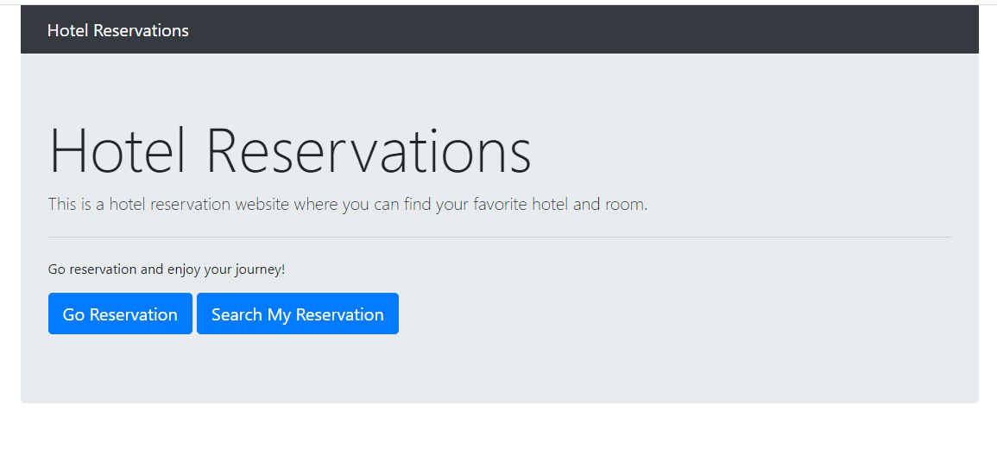

This is the “Hotel Reservation” homepage. The user can either make a reservation or search an existing reservation. Each page subsequent has the “Hotel Reservations” banner as a link to the homepage.

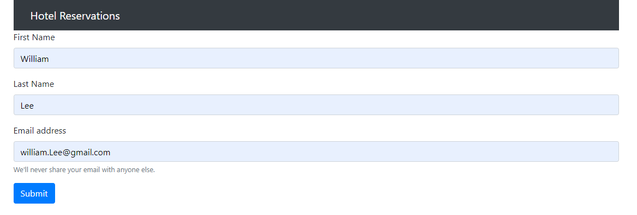

If the user chooses to make a reservation, this is the page where he/she can enter his/her first name, last name, and email address.

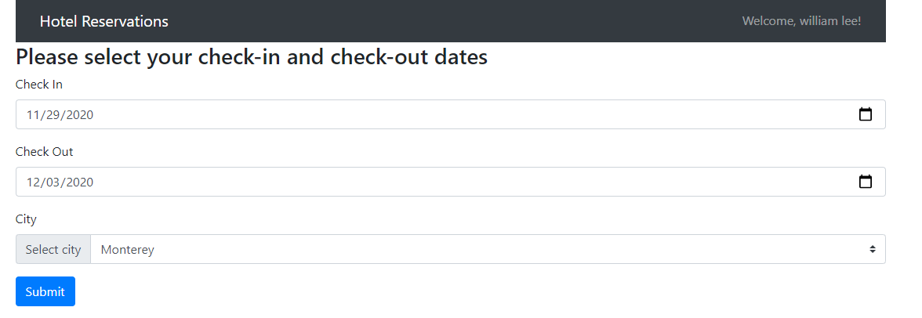

The user can then select the check-in and check-out dates via dropdown calendar options. He/she can also select from 3 cities from which to seek hotels: Honolulu, Monterey, and San Diego.

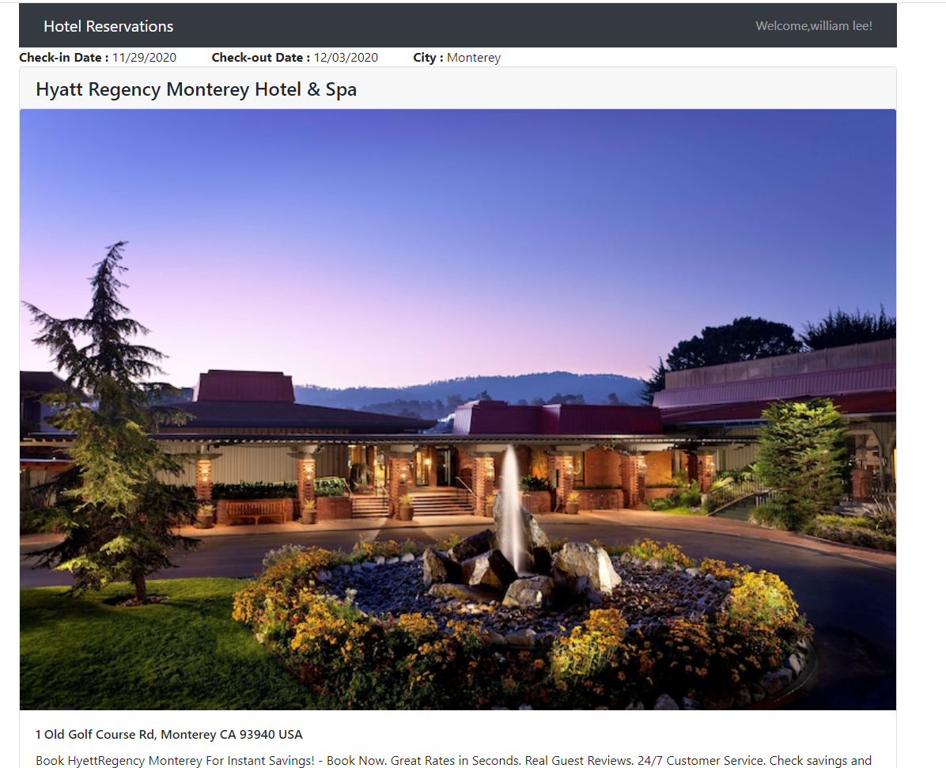

The user can select a hotel after selecting the city.

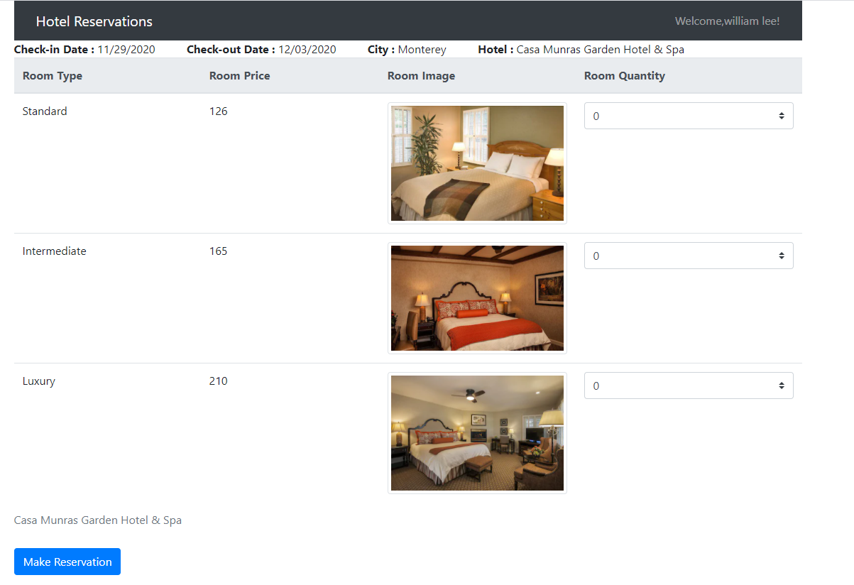

After selecting a hotel, the user can now select types and number of rooms per type: Standard, Intermediate or Luxury.

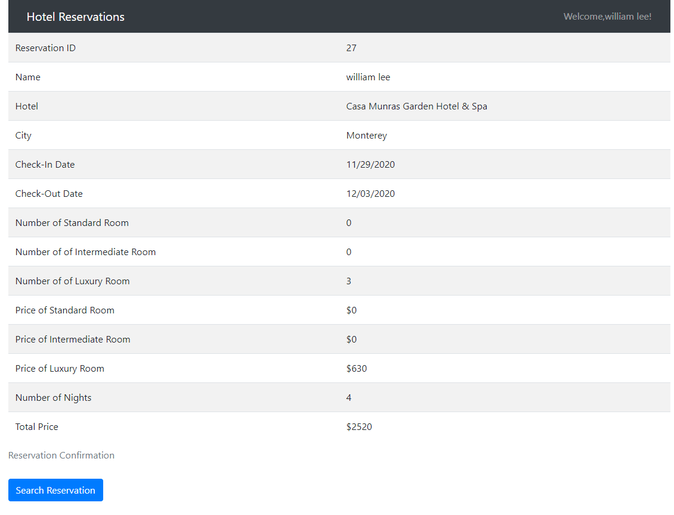

Once the user finishes making a reservation, this page serves as a reservation confirmation and online receipt providing a Reservation ID number and other information regarding the reservation. The user can either go back to the homepage via the banner link or click on the button “Search Reservation,” which also appears on the homepage.

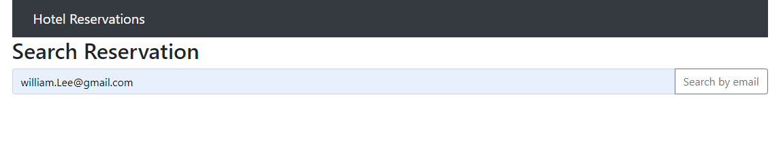

If the user ever clicks on the “Search Reservation” buttons he/she will land on this page and has the option to find one reservation based on the user’s email address.

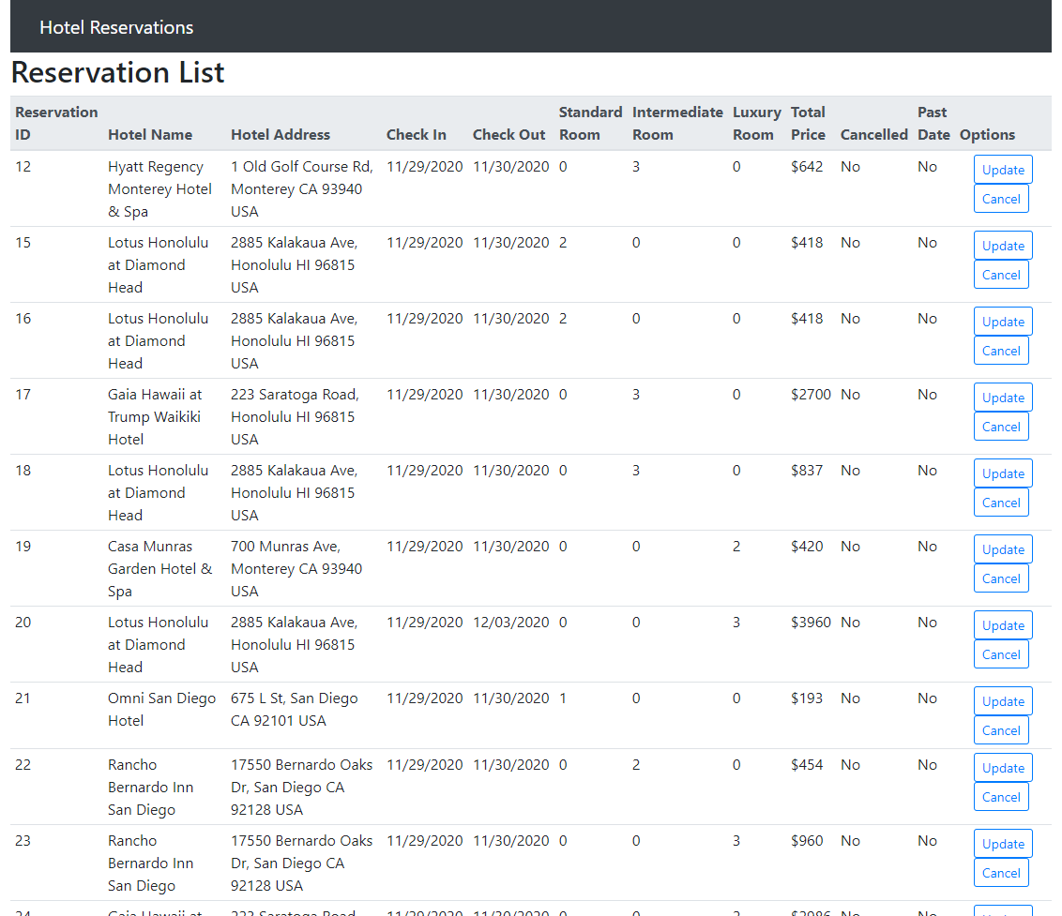

Once the user search reservations by email address, this page lets the user view information about the reservations and has the option to either update the reservation or cancel it.

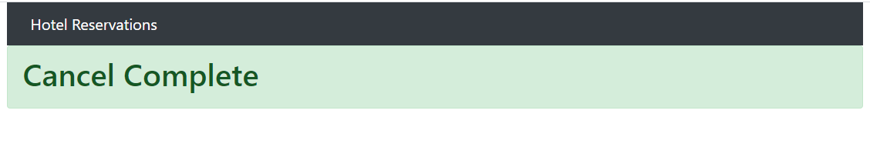

If the user chooses to cancel the reservation, he/she is taken to this page, notifying him/her that the reservation was cancelled successfully.

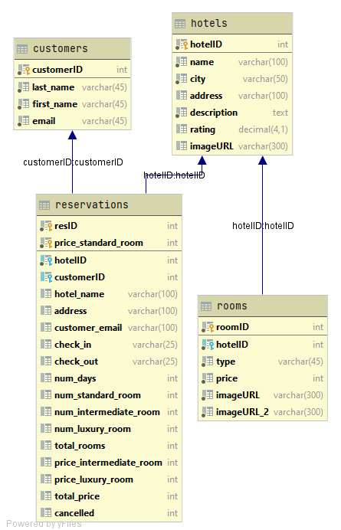

This graph shows the database design.

# 02 The problem we met

As we are still in China, there are time differences and problems with the internet. The speed of downloading some files is often very slow. The software was not available when configuring the Eclipse environment, which slowed us down even more. In the end we had to use Intellij IDEA to continue with the project.

Thank you very much for your understanding. It was later than expected, but we finally finished the project.

Thank you and all the best to you!